B1

Predicted Output
Compiles successfully.
The program prints: 3.99
Reason
The student's GPA is changed only in memory. Since SaveChangesAsync() is never called, the database is not updated, so the stored GPA remains unchanged.

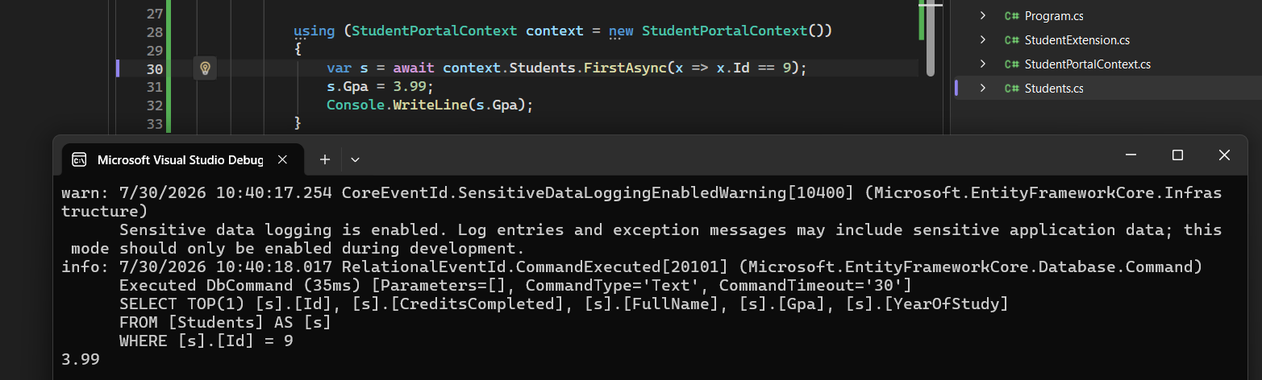

B2
Hamdy: 0
Mona: 0
Because lazy loading is disabled and the Courses navigation property was not loaded.
It was initialized as an empty list (new List<Course>()), so Count is 0.
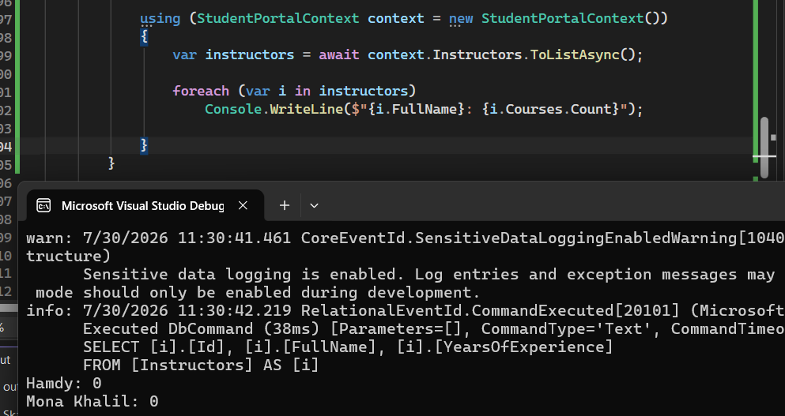

B3

Answer
No changes will be saved to the database.

AsNoTracking() returns an entity that is not tracked by EF Core.
Changing its properties is ignored because the Change Tracker does not detect the modification.

This is dangerous because the program runs without any exception, but the database remains unchanged.

